**Obstacle Avoiding Robot**

**Introduction**

Obstacle Avoiding Robot is an intelligent device which can automatically sense the obstacle in front of it and avoid them by turning itself. The basic principle behind the working of ultrasonic sensor is to note down the time taken by sensor to transmit ultrasonic beams and receiving the ultrasonic beams after hitting the surface. Then further the distance is calculated using the formula. In this project, the widely available **HC-SR04 Ultrasonic Sensor** is used.

Components

* Arduino NANO or Uno (any version)
* 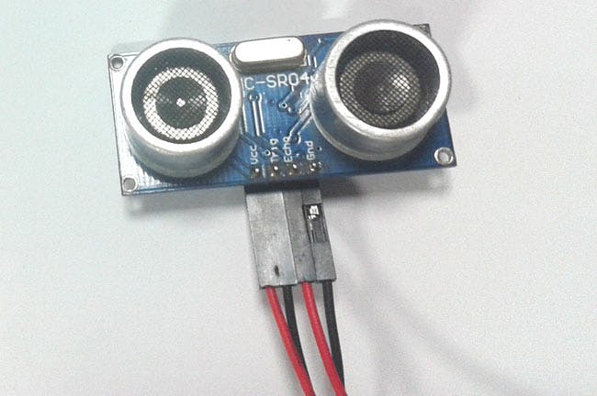HC-SR04 Ultrasonic Sensor
* LM298N Motor Driver Module
* 5V DC Motors
* Battery
* Wheels
* Chassis
* Jumper

Application

* Counting people/people detection
* Presence detection
* Detecting breaks in threads or wires
* Box sorting
* Contouring or profiling
* Irregular parts detection
* Tank level detection

Objective

During this activity ,you will help students to achieve following objectives

1. Understanding the principle and operation of HC-06 ultrasonic sensor
2. Design algorithm and flowchart to detect obstacle and avoid obstacle.
3. Programming HC-06 ultrasonic sensor module using Arduino nano
4. Interfacing HC-06 ultrasonic sensor module with Arduino nano

Flowchart

Program

int trigPin = 9; // trig pin of HC-SR04

int echoPin = 10; // Echo pin of HC-SR04

int revleft4 = 4; //REVerse motion of Left motor

int fwdleft5 = 5; //ForWarD motion of Left motor

int revright6 = 6; //REVerse motion of Right motor

int fwdright7 = 7; //ForWarD motion of Right motor

long duration, distance;

void setup() {

delay(random(500,2000)); // delay for random time

Serial.begin(9600);

pinMode(revleft4, OUTPUT); // set Motor pins as output

pinMode(fwdleft5, OUTPUT);

pinMode(revright6, OUTPUT);

pinMode(fwdright7, OUTPUT);

pinMode(trigPin, OUTPUT); // set trig pin as output

pinMode(echoPin, INPUT); //set echo pin as input to capture reflected waves

}

void loop() {

digitalWrite(trigPin, LOW);

delayMicroseconds(2);

digitalWrite(trigPin, HIGH); // send waves for 10 us

delayMicroseconds(10);

duration = pulseIn(echoPin, HIGH); // receive reflected waves

distance = duration / 58.2; // convert to distance

delay(10);

// If you dont get proper movements of your robot then alter the pin numbers

if (distance > 19)

{

digitalWrite(fwdright7, HIGH); // move forward

digitalWrite(revright6, LOW);

digitalWrite(fwdleft5, HIGH);

digitalWrite(revleft4, LOW);

}

if (distance < 18)

{

digitalWrite(fwdright7, LOW); //Stop

digitalWrite(revright6, LOW);

digitalWrite(fwdleft5, LOW);

digitalWrite(revleft4, LOW);

delay(500);

digitalWrite(fwdright7, LOW); //movebackword

digitalWrite(revright6, HIGH);

digitalWrite(fwdleft5, LOW);

digitalWrite(revleft4, HIGH);

delay(500);

digitalWrite(fwdright7, LOW); //Stop

digitalWrite(revright6, LOW);

digitalWrite(fwdleft5, LOW);

digitalWrite(revleft4, LOW);

delay(100);

digitalWrite(fwdright7, HIGH);

digitalWrite(revright6, LOW);

digitalWrite(revleft4, LOW);

digitalWrite(fwdleft5, LOW);

delay(500);

}

}

Hardware

